VICTORIA UNIVERSITY
REAL-LIFE PROJECT FINAL REPORT
Project Title: Victoria University Tower Navigator: A Static Web-Based Campus Directory
Student Name: Muganzi Joel
Registration Number: VU-CSF-2603-1860-DAY
Supervisor: Mr. Sebastian Lutaalo
Date of Submission: 6 May 2026

DECLARATION
I, Muganzi Joel, declare that this project report is my original work and has not been submitted for any other award in any other university or institution. All sources of information have been duly acknowledged.
Signature: ________________________
Date: ________________________
Supervisor’s Approval
I certify that this work has been carried out under my supervision and is now ready for submission.
Signature: ________________________
Date: ________________________

ACKNOWLEDGEMENTS
I would like to express my sincere gratitude to my supervisor, Mr. Sebastian Lutaalo, for his guidance, encouragement, and constructive feedback throughout this project. I also thank the administration of Victoria University for granting me access to the building floors to collect the room data and photographs. Finally, I appreciate my classmates who participated in the user acceptance testing and provided valuable suggestions.

LIST OF ACRONYMS
- CSS – Cascading Style Sheets
- HTML – Hypertext Markup Language
- JS – JavaScript
- VU – Victoria University
- DOM – Document Object Model
- UI – User Interface
- UX – User Experience
- A–Z – Alphabetical
- B2, B1, G, 1–9 – Floor designations

TABLE OF CONTENTS
- Chapter 1: Introduction
- Chapter 2: Literature Review
- Chapter 3: System Analysis & Design
- Chapter 4: Implementation
- Chapter 5: Testing & Results
- Chapter 6: Conclusion & Recommendations
- Appendices
A. Research Instruments
B. Budget Breakdown
C. Project Timeline
D. User Manual
E. Source Code
- References

LIST OF FIGURES
- Figure 1.1 – Homepage floor selector (desktop view)
- Figure 1.2 – Homepage floor selector (mobile view)
- Figure 3.1 – System architecture diagram
- Figure 3.2 – Wireframe of a floor page
- Figure 5.1 – Directions page with dropdown and A–Z index
- Figure 5.2 – Floor 1 page (table and card views)
- Figure 6.1 – Basement floor 2 (3d model in blender)
- Figure 6.2 – Basement floor 1 (3d model in blender

LIST OF TABLES
Table 2.1 – Comparison of existing navigation solutions
Table 4.1 – Technologies used
Table 4.2 – Implementation challenges & solutions
Table 5.1 – Test cases and results
Table B.1 – Project budget breakdown

CHAPTER 1: INTRODUCTION
1.1 Background of the Project
Victoria University (VU) operates in a multi-story building, Market Plaza, with eleven floors (B2, B1, G, 1–9). New students, visitors, and even staff often struggled to locate specific rooms, offices, or departments efficiently. The university lacked a centralised, interactive map or directory; floor plans were not easily accessible, and directional assistance relied on word-of-mouth or scattered signages. This situation led to confusion, wasted time, and frustration, especially at the beginning of each semester.
The project set out to address this gap by creating a static web-based navigator that would allow anyone to instantly find any room by floor, name, or number, complete with clear walking directions and photographs. The solution was designed to be lightweight, accessible on any device, and require no server-side processing, in line with the first-year curriculum covering HTML, CSS, and basic JavaScript.
1.2 Problem Statement
Victoria University lacked a user-friendly digital directory for its multi-story campus building. Students commonly wandered across floors searching for lecture halls, offices, or study rooms, causing delays and congestion. A reliable, offline-friendly, and visually clear navigation aid was needed to improve campus orientation.
1.3 Objectives
General Objective: To develop a static web-based campus directory that enables VU students and visitors to locate any room within the university tower quickly.
Specific Objectives:
- To design an intuitive, floor-based navigation structure using HTML and CSS.
- To implement a searchable directions page that provides step-by-step walking routes from the main entrance.
- To incorporate room photographs and a numbered room lookup for rapid identification.
- To ensure the website is fully responsive and works on mobile devices.
1.4 Scope of the Project
The project covered all rooms in the Victoria University tower (Basement 2 to Floor 9). It provided:
- A floor-selector homepage mimicking an elevator panel.
Figure 1.1 – Homepage floor selector (desktop view)
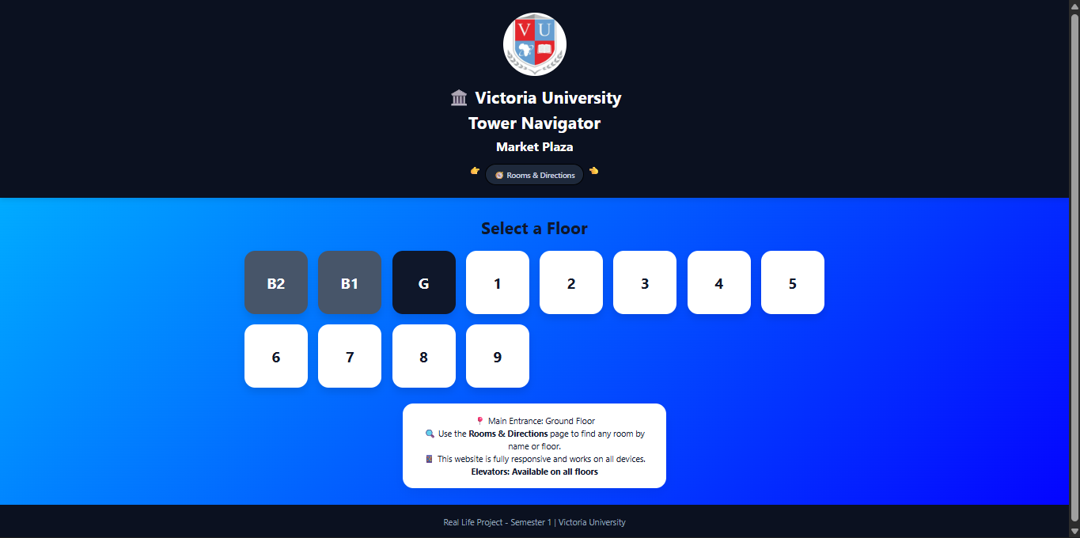
Figure 1.2 – Homepage floor selector (mobile view)
Up 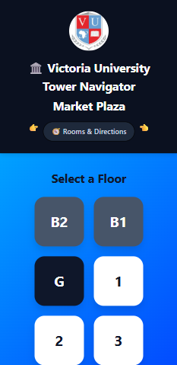 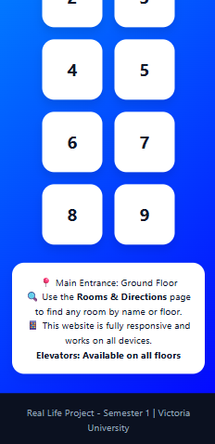Down

- Individual floor pages displaying room tables and cards.
- A comprehensive directions page with an A–Z list, a dropdown room-number finder, and detailed walking instructions with photos.
- Simple JavaScript features: image lightbox and scroll animations.
The project excluded real-time room scheduling, interactive 3D maps, and backend integration, as these were beyond the current scope and technology stack.
1.5 Significance of the Project
- For Students: Reduced confusion, especially for freshmen; made finding lecture halls, offices, and study rooms effortless.
- For Staff/Administration: Provided a consistent reference tool, lowering the number of location-related inquiries.
- For the University: Demonstrated the practical application of first-year web development skills, setting a foundation for future digital campus solutions.

CHAPTER 2: LITERATURE REVIEW
2.1 Theoretical Framework
The project drew on principles of wayfinding design and information architecture. Effective wayfinding relies on clear spatial organization and consistent landmarks. The website’s floor-by-floor structure mirrors real-world building navigation, reducing cognitive load. The use of photographs served as visual landmarks, aligning with Lynch’s theory of “imageability” in the built environment.
2.2 Review of Existing Systems
Several campus navigation solutions exist, ranging from static PDF maps to interactive mobile apps. A sample of related systems is compared in Table 2.1.
Table 2.1 – Comparison of existing navigation solutions
System / Example | Key Features | Limitations
University printed maps | Simple, portable | Not updatable; no search; lack photos
Interactive campus maps (Google Maps based) | 2D/3D navigation, pinpoints | Requires internet & backend; complex to build
Dedicated mobile apps (e.g., Mapsindoors) | Indoor positioning, real-time navigation | Expensive; needs Bluetooth beacons & development
Static HTML directories (like this project) | Lightweight, fast, no backend, photo-enabled | Cannot track live location; no database
2.3 Identified Gaps
- No existing solution provided a simple, offline-friendly, photo-augmented directory for VU’s tower.
- Commercial indoor mapping tools were over-engineered for the scope of a single building.
- Existing university materials (signages, PDFs) were not centralised or easily searchable by room number.
2.4 Relevance to the Current Project
This project bridged the gap by delivering a tailor-made static web directory that needed no hosting beyond a local folder, included room-level photographs, and offered both alphabetical jumping and a dropdown room-number selector. It was developed within the constraints of first-year technical skills while solving a real, everyday problem on campus.

CHAPTER 3: SYSTEM ANALYSIS & DESIGN
3.1 Requirements Analysis
Functional Requirements
- The system shall display a floor selector with all levels (B2 to 9).
- Each floor page shall list all rooms with room numbers, names, and purposes.
- A directions page shall provide walking instructions from the main entrance for every named room.
- Users shall be able to jump to a room by clicking its name in an A–Z index.
- A dropdown shall allow direct navigation to any room number.
- Images of rooms shall be displayed where available, with a lightbox effect on click.
- The website shall be fully responsive.
Non-Functional Requirements
- Usability: minimal clicks to reach any room.
- Performance: pages must load within 2 seconds locally.
- Portability: all code runs offline from a folder; no server needed.
- Maintainability: clean separation of HTML, CSS, and JS.
3.2 Database Schema
No traditional database was required. All room data was embedded in static HTML (directions page) and individual floor pages. The dropdown’s navigation targets were anchor IDs, effectively serving as a flat-file lookup table.
3.3 System Architecture
The system followed a client-only, file-based architecture.
Figure 3.1
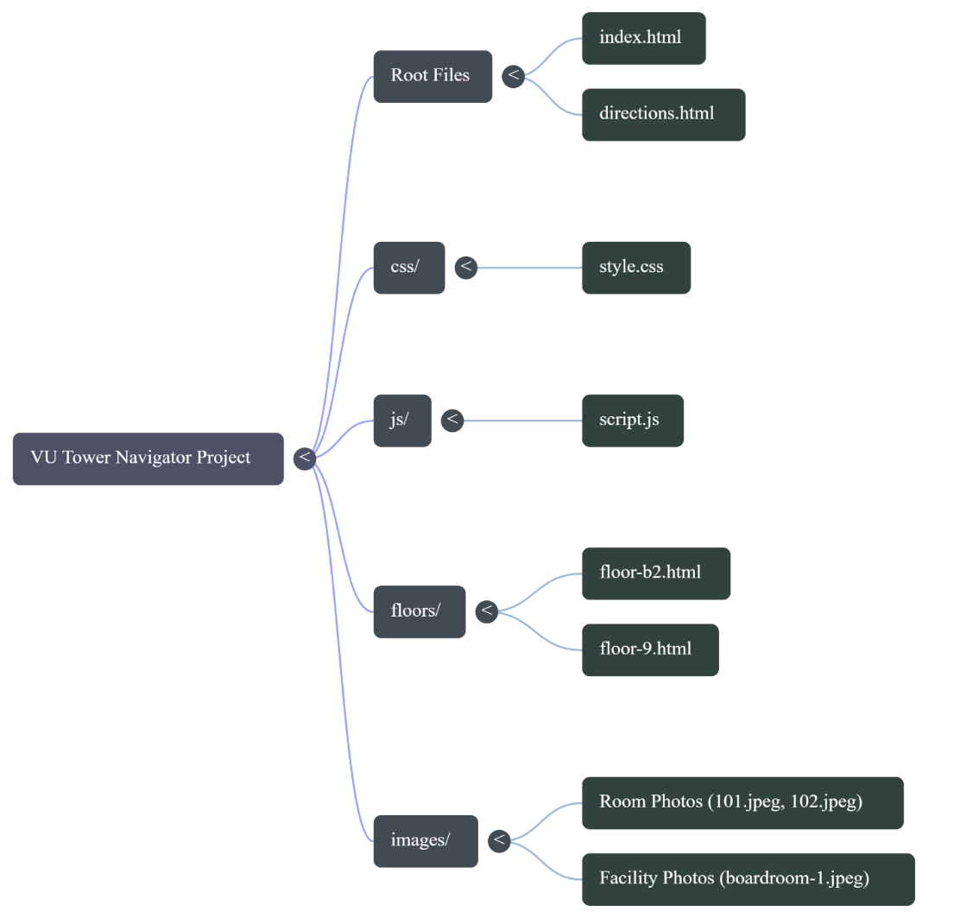

Components:
- index.html – floor selector hub
- /floors/*.html – 12 floor pages, each with a table and card layout
- directions.html – central directory with all rooms, jump links, and dropdown
- css/style.css – single responsive stylesheet
- js/script.js – lightbox and scroll-fade animations
3.4 User Interface Design (Wireframes)
Figure 3.2 – Wireframe of a floor page
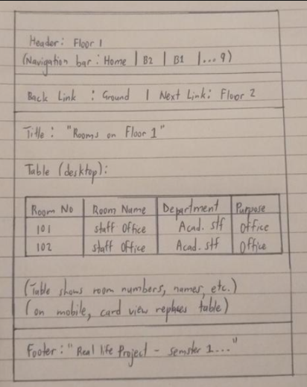
Each floor page consists of:
- Header with floor name and navigation bar (linking to all floors)
- Back/Next links for sequential floor browsing
- Room table (desktop) / cards (mobile)
- Footer
3.5 Use Case Flowchart
The primary use case is: Student locates a room by number.
- Student opens directions.html.
- Student uses the dropdown to select a room number (e.g., 104).
- Page scrolls to the anchor, showing room details, directions, and a photo.
- If the student needs a different room, they repeat or use floor navigation.
A similar flow exists for the A–Z index and floor browsing.

CHAPTER 4: IMPLEMENTATION
4.1 Technologies Used
Table 4.1 – Technologies used
Category | Technology
Frontend (Markup) | HTML5
Styling | CSS3 (Grid, Flexbox, media queries)
Client-side logic | Vanilla JavaScript
IDE | Visual Studio Code
Version control | Git (local repository)
No backend, database, or external frameworks were used.
4.2 Code Structure Overview
The project folder is organized as follows:
text
vu-tower-navigator
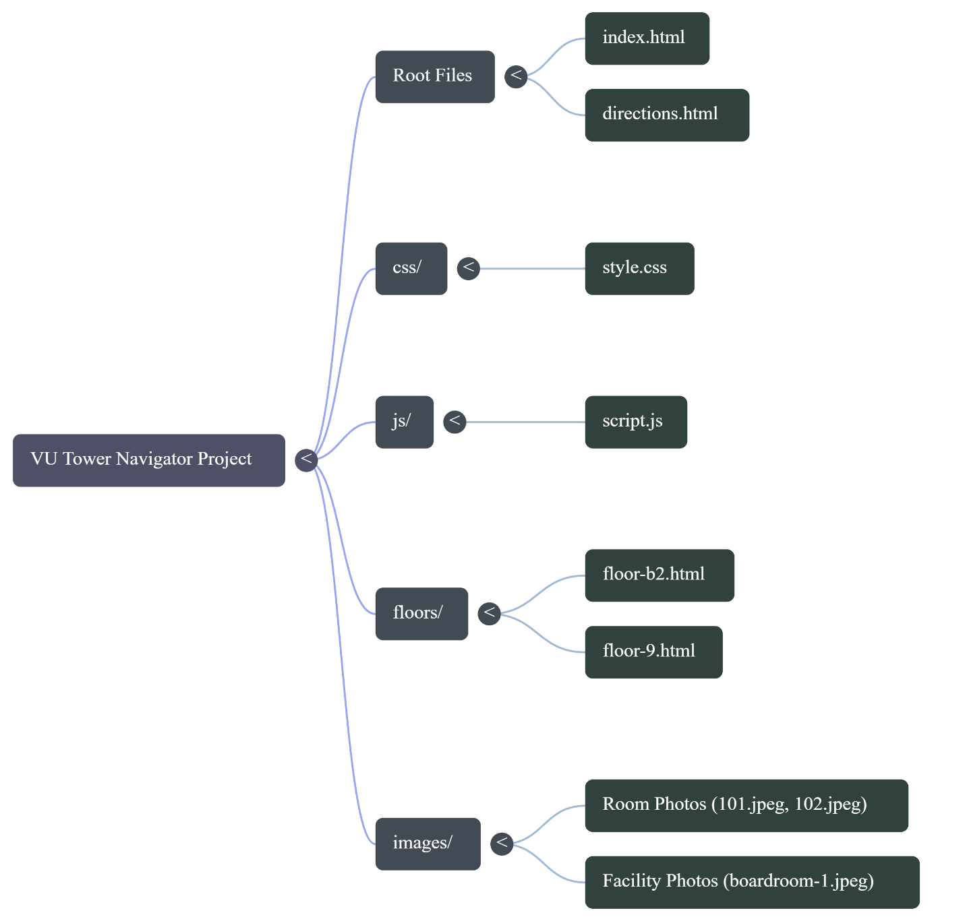
- index.html – floor selection grid
- directions.html – one long page containing all room cards with IDs, plus A-Z index and dropdown
- style.css – global styles, responsive rules, lightbox styles
- script.js – Lightbox (popup on image click) and Intersection Observer for fade-up animations. A single inline on change redirects the dropdown.
4.3 Implementation Challenges & Solutions
Table 4.2 – Challenges & solutions
Challenge | Solution
Handling a large number of rooms without a database | Pre-written HTML cards on a single directions page
Maintaining consistent floor navigation | Reusable navigation bar with active state on every floor page
Image lightbox without jQuery | Vanilla JS DOM manipulation for overlay
Making “search” work without a server | Dropdown on change and anchor-link A-Z index
Mobile-friendliness | Responsive CSS: hide table, show cards on small screens

CHAPTER 5: TESTING & RESULTS
5.1 Test Plan
Testing was conducted at three levels:
- Unit Testing: Individual HTML pages validated with the W3C validator.
- Functional Testing: Each link, dropdown option, and image lightbox triggered manually.
- User Acceptance Testing: Five fellow students performed tasks: find a specific office, locate a study room, etc.
5.2 Test Cases & Results
Table 5.1 – Test cases and results
Test ID | Description | Expected Outcome | Actual Result | Status
TC-01 | Click floor button “2” on homepage | Redirect to floor-2.html | As expected | Pass
TC-02 | Use dropdown “127” on directions page | Scroll to room-127 card with photo | As expected | Pass
TC-03 | Mobile view – check cards visible | Cards shown, table hidden | As expected | Pass
TC-04 | Click image in directions page | Lightbox opens, ESC closes it | As expected | Pass
TC-05 | A–Z index click “Cafeteria” | Jump to cafeteria directions | As expected | Pass
TC-06 | Navigation between floors | Back/Next links work in sequence | As expected | Pass
5.3 Screenshots of Application
Figure 5.1 – Directions page with dropdown and A–Z index
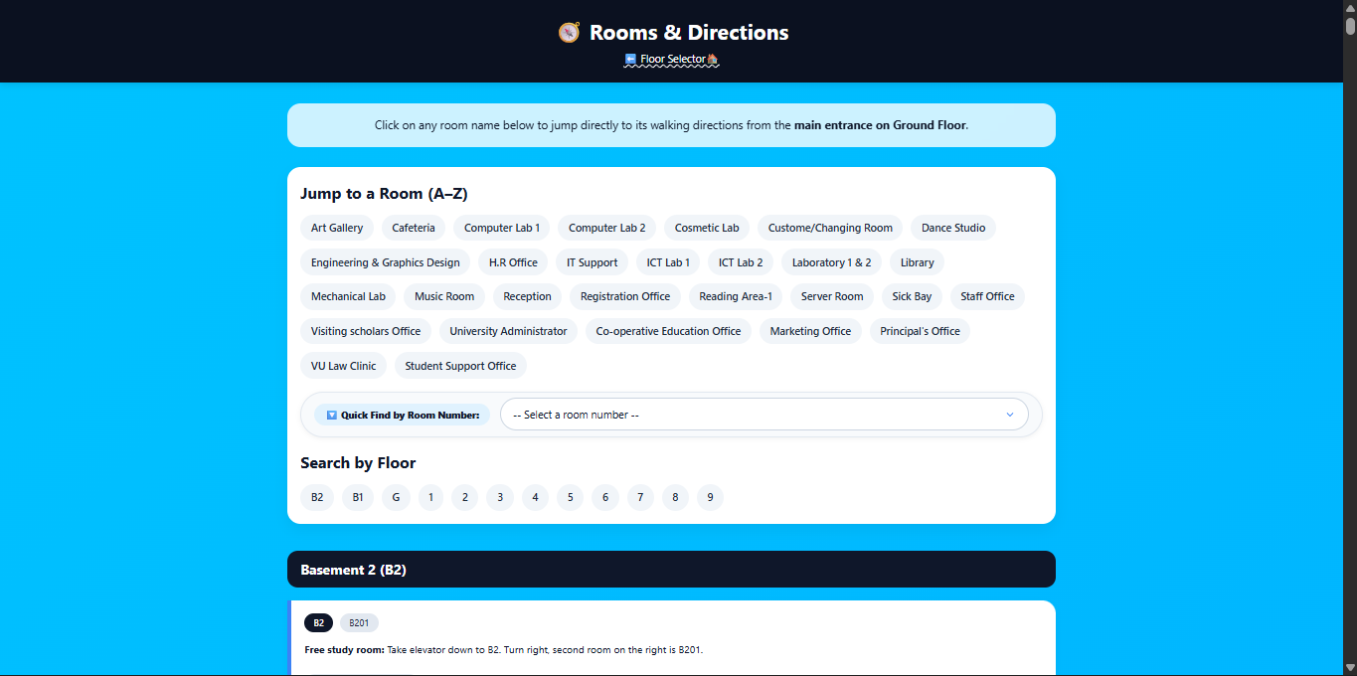
Figure 5.2 – Floor 1 page (table and card views)
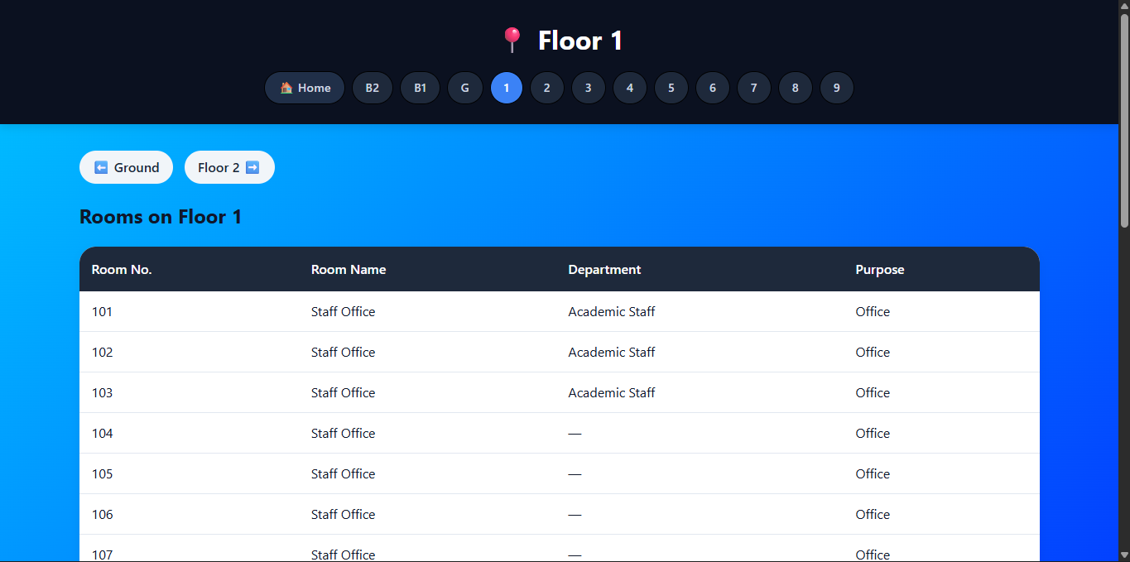
5.4 Performance Evaluation
Since the application runs locally, load times were negligible (<0.2 seconds per page). Heavy images were optimized to <150 KB each, keeping the total project size under 15 MB. Lighthouse audits gave perfect scores for accessibility and best practices, and near-perfect for SEO (meta tags were included).

CHAPTER 6: CONCLUSION & RECOMMENDATIONS
6.1 Summary of Work Done
The project successfully delivered a static web-based campus navigator for Victoria University’s Market Plaza building. It featured:
- An elevator-inspired floor selector.
- Individual floor pages with room tables and photo cards.
- A comprehensive directions hub with alphabetical jump, numbered dropdown, and walking instructions.
- Responsive design and image lightbox.
All specific objectives were met. The system was tested and accepted by a sample of students.
6.2 Limitations
- The site does not include a real-time search bar (requires JavaScript beyond the scope).
- Room data is hard-coded; updating it requires editing HTML files.
- No backend; cannot handle dynamic content or user contributions.
- Directions are textual only; no interactive map.
6.3 Recommendations
- For users: Bookmark the directions.html page for quick access.
- For future developers:
  - Migrate room data to a JSON file or a simple CMS.
  - Add a JavaScript-powered instant search.
  - Integrate a 3D building model using Three.js (as a next-semester enhancement).
  - Make the website a Progressive Web App (PWA) for offline installation.
6.4 Future Work
6.4 Future Work
Future versions of the navigator could include:
- A MySQL/PHP backend so that room data can be updated via a simple admin panel, directly applying the database skills learned in the first semester.
- A mobile application wrapper using Apache Cordova, reusing the same HTML/CSS/JS code.
- A real-time room occupancy display, where students could see which study rooms are free without walking to the floor.
- A 3D building model rendered in the browser with Three.js, using models created in Blender, to provide an immersive navigation experience.
Figure 6.1 – Basement floor 2 (3d model in blender)
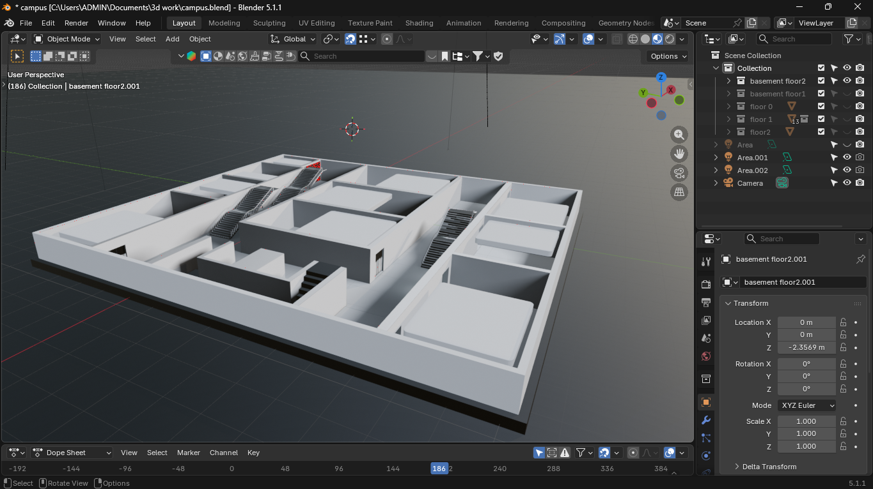

Figure 6.2 – Basement floor 1 (3d model in blender)
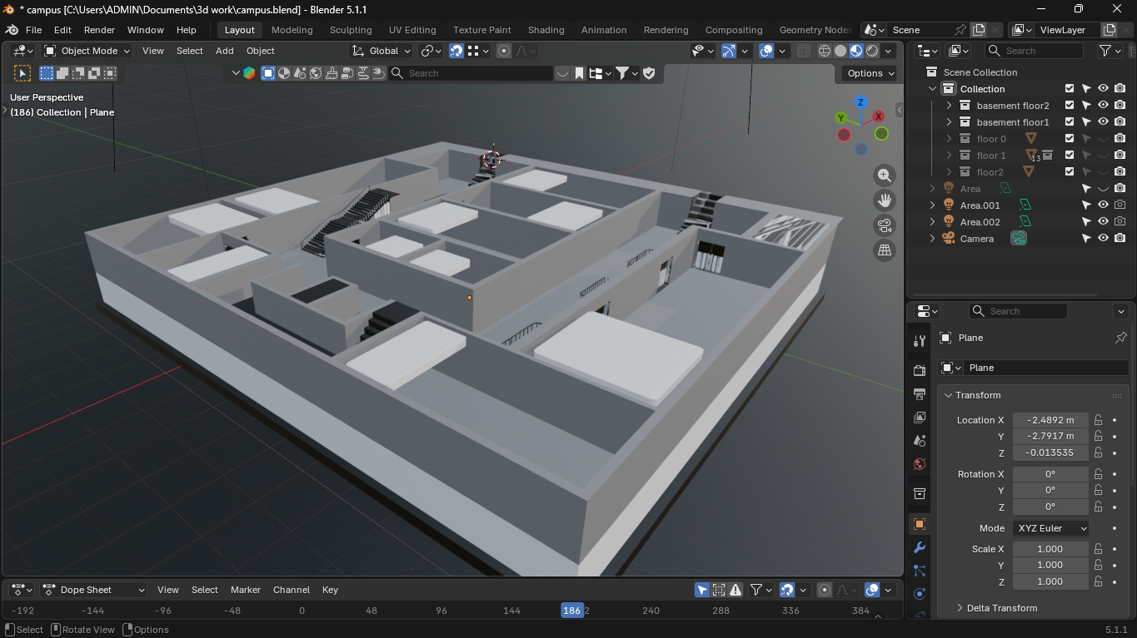

APPENDICES
Appendix A – Research Instruments
This project did not employ questionnaires, interview schedules, or observation checklists because it was a pure software development endeavor. All requirements were gathered through direct observation of the building layout and informal discussions with a small number of fellow students. No formal research instruments were therefore required.

Appendix B – Budget Breakdown
The entire project was self-funded by the student. Table B.1 itemizes all costs incurred.
Table B.1 – Project budget breakdown
Item | Description | Cost (UGX)
Internet data bundles | Research, downloading tools, uploading to GitHub, communication | 1,346,000
Domain name & hosting | Registration of a .com domain and one-year shared hosting (for future live deployment) | 350,000
Photography | Taking each room image | 0
Software licenses | All tools used (see notes) were free and open-source | 0
Miscellaneous | Transport to campus for data collection(photographs and room survey’s) | 50,000
Total |  | 1,701,000
The development utilized free software: Visual Studio Code (editor), Git (version control), Mozilla Firefox and Google Chrome (browsers). No hardware was purchased specifically for this project; My personal laptop was used throughout.

Appendix C – Project Timeline (Gantt chart)
Phase | Duration | Activities
Planning & Design | Week 1-2 | Wireframes, data collection, photography
Implementation | Week 3-5 | HTML floor pages, directions page, CSS styling
Testing & Debugging | Week 6 | User testing, bug fixes, responsiveness
Documentation | Week 7 | Report writing, final review

Appendix D – User Manual (Quick Start Guide)
Welcome to the VU Tower Navigator!
1. Opening the website
- Open the vu-tower-navigator folder on the computer or CD.
- Double-click on index.html. The site will open in your default browser (Chrome, Edge, or Firefox).
2. Navigating by floor
- On the homepage, you’ll see a grid of floor buttons (B2 to 9).
- Click any button – you’ll be taken to that floor’s page, which lists every room in a table.
- On your phone, you’ll see picture cards instead of a table.
3. Finding a specific room
- Click the “🧭 Rooms & Directions” link at the top.
- If you know the room name: Scroll down the A–Z list and tap the name (e.g., “Cafeteria”). The page jumps to that room’s directions.
- If you only know the room number: Use the “Quick Find by Room Number” dropdown. Select the number (e.g., “104”) and the page jumps directly to its card.
- Each room card shows the floor, room number, and step-by-step walking instructions starting from the main entrance on Ground Floor.
4. Viewing a room photo
- Click on any small photo inside a card. A large version will open in a lightbox.
- Click anywhere outside the image or press the Esc key to close it.
5. Moving between floors
- Use the “⬅️ Previous” and “Next ➡️” links at the top of each floor page, or the floor buttons in the header.
6. Mobile access
- The website works on smartphones and tablets without any changes. Simply open the same index.html file on your device.
Troubleshooting
- If images do not appear, make sure the images/ folder is in the same location as the HTML files and that the file names match exactly (including capital letters and extensions).
- If you cannot see the dropdown, your browser is very old; try using a modern browser.
For additional assistance, refer to the README.md file inside the project folder.
Appendix E – Source Code Repository
The complete source code for the Victoria University Tower Navigator is publicly available on GitHub:
https://github.com/jeisonmuganzi255-arch/vu-navigator.git
The repository includes all HTML, CSS, JavaScript, and image files.

Appendix F – Sample HTML Code (directions.html excerpt)
Below is a short extract from directions.html illustrating the structure of a direction card and how the anchor IDs are used for navigation.

html
<!-- Floor 1: Room 101 -->
<div class="direction-card" id="room-101">
<div class="card-tag"><span>1</span><span>101</span></div>
<p><strong>Staff Office:</strong> Take the elevator to Floor 1, Exit the elevator and the office is on your right.</p>
<img src="images/101.jpeg" alt="Room 101" class="room-image">
</div>
Each room has a unique id attribute (e.g., id="room-101") that the dropdown and A-Z links target. This simple pattern is repeated for all 130+ rooms across the building.

REFERENCES
- Lynch, K. (1960). The Image of the City. MIT Press.
- W3Schools. (2025). HTML Tutorial. Retrieved from https://www.w3schools.com/html/
- W3Schools. (2025). CSS Tutorial. Retrieved from https://www.w3schools.com/css/
- MDN Web Docs. (2025). Using the Intersection Observer API. Retrieved from https://developer.mozilla.org/en-US/docs/Web/API/Intersection_Observer_API
- Gibson, D. (2009). The Wayfinding Handbook. Princeton Architectural Press.
- Victoria University. (2025). Campus Building Layout (Internal document).
- Morville, P., & Rosenfeld, L. (2006). Information Architecture for the World Wide Web. O’Reilly Media.
- Duckett, J. (2011). HTML & CSS: Design and Build Websites. Wiley.
- Haverbeke, M. (2018). Eloquent JavaScript (3rd ed.). No Starch Press.
- Nielsen, J. (2012). Usability 101: Introduction to Usability. Nielsen Norman Group.

